Go to your swim portal on Active and sign in with the user name and password you registered with. Notify us ASAP if you are having issues logging in or if your screens do not look like the ones below!

[https://swimportal.active.com?a=283065302](https://swimportal.active.com/?a=283065302)

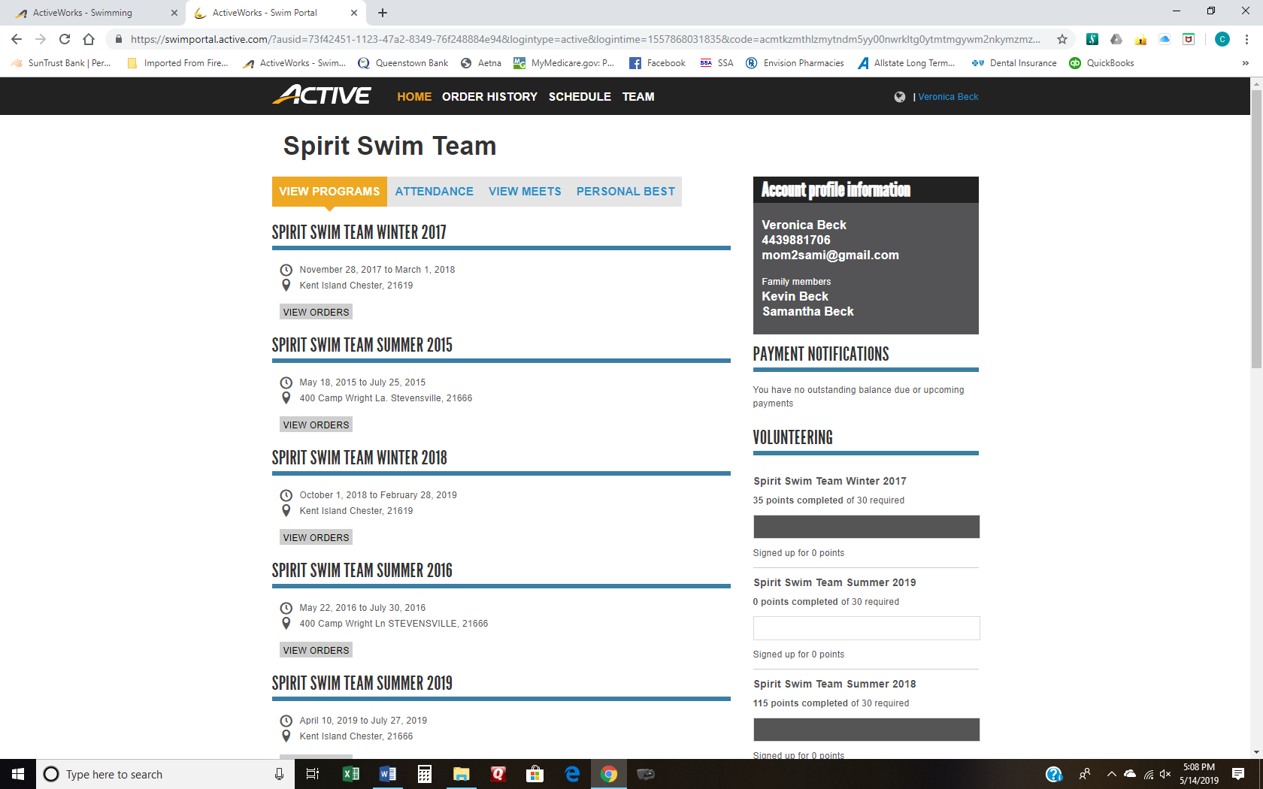

Your home page looks like this once you log in.

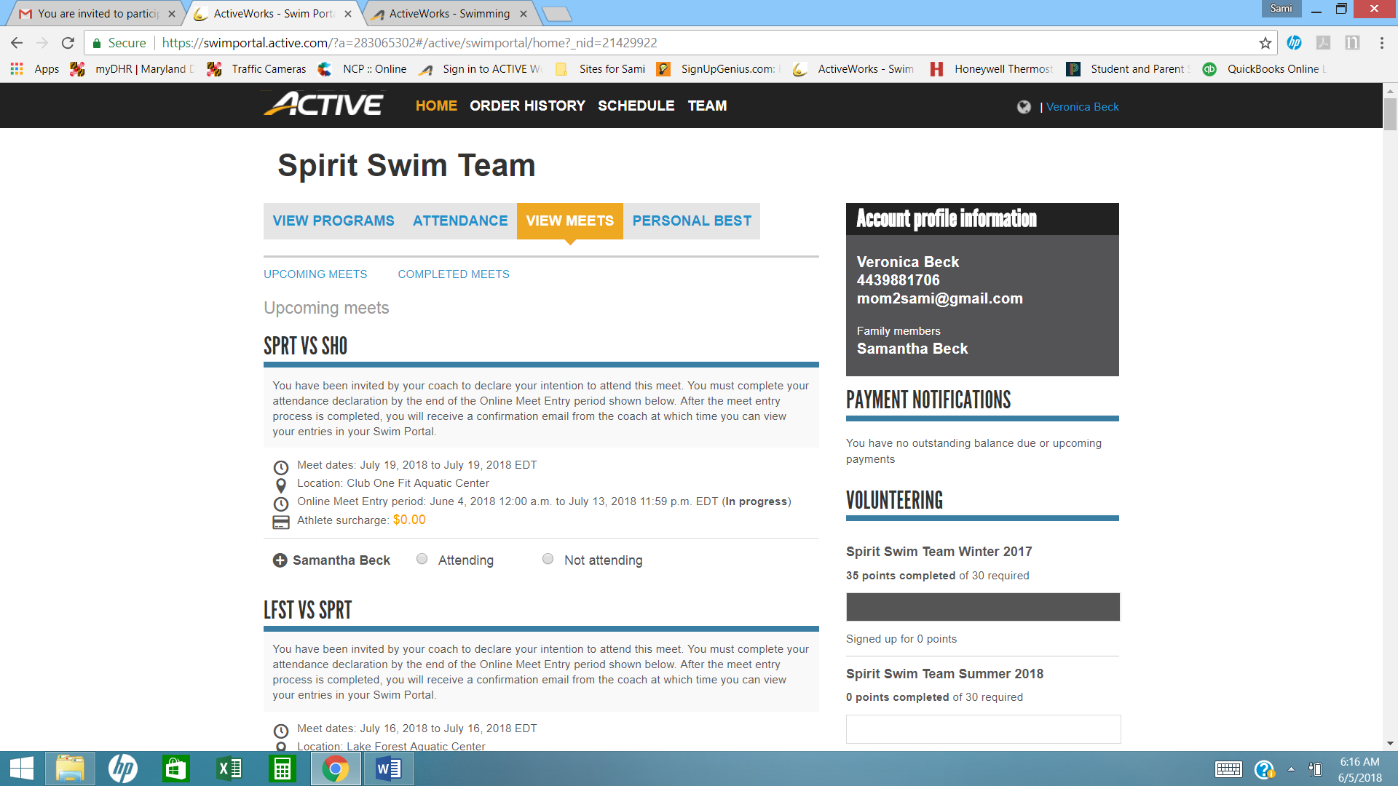

Your meets are listed on the VIEW MEETS tab. Pay attention to:

* The date of the meet
* The location of the meet – go to [www.delmarvaswim.org](http://www.delmarvaswim.org) to get team meet location addresses. Click on Teams on the home page.
* The period that you have to make your selections of Attending or Not Attending.
* If you do not SIGN IN for the meet, we will not be emailing you to confirm. Your swimmer will be marked as NOT ATTENDING.

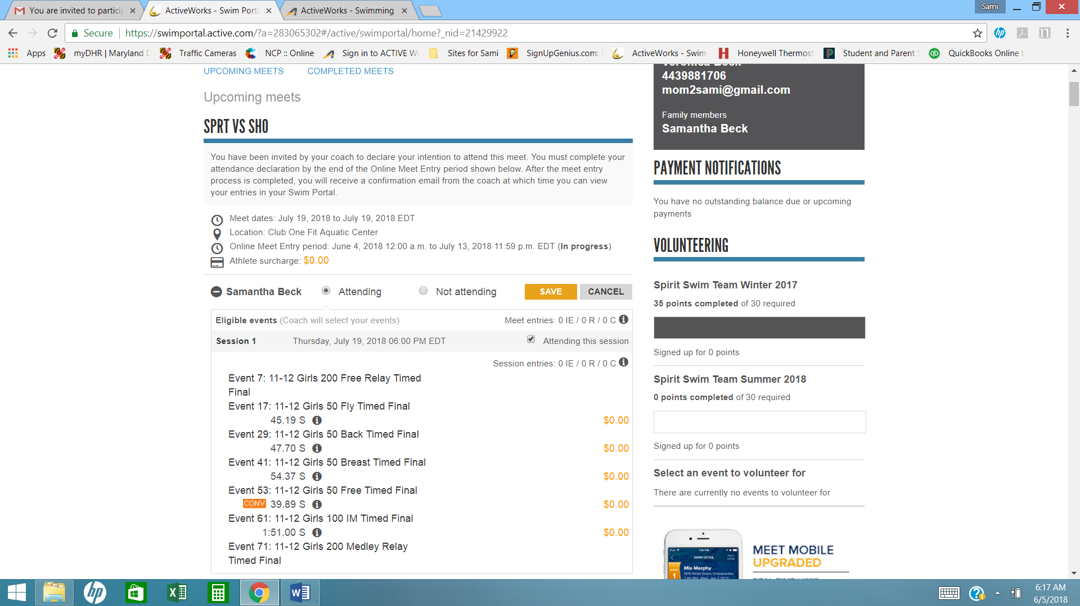

Click on Attending or Not Attending for EACH MEET listed. Then click SAVE! If you do not hit Save, your selection was NOT recorded. **You do not need to select the events for the regular season dual meets.**

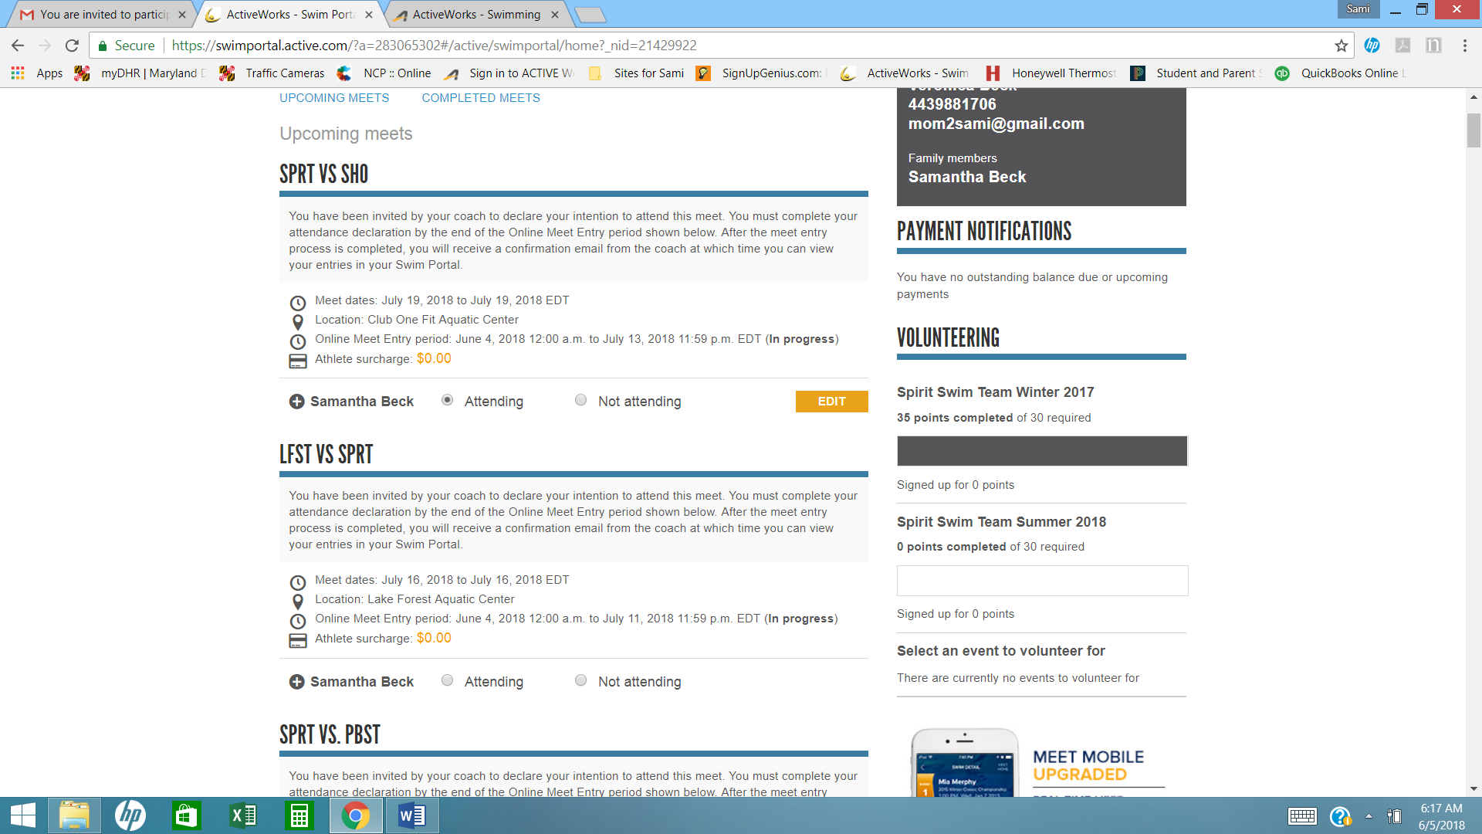

Once you have made your selection and hit Save, it should look like the meet listed as SPRT VS SHO. If your event does not look like this, your selection was not made properly.

Sign your swimmers in and out as soon as possible…then you won’t forget to do so as the season gets underway. Once the meets start, the weeks are crazy. Sign them in or out within the next two weeks. **Our first meet is Thursday, June 23rd!**

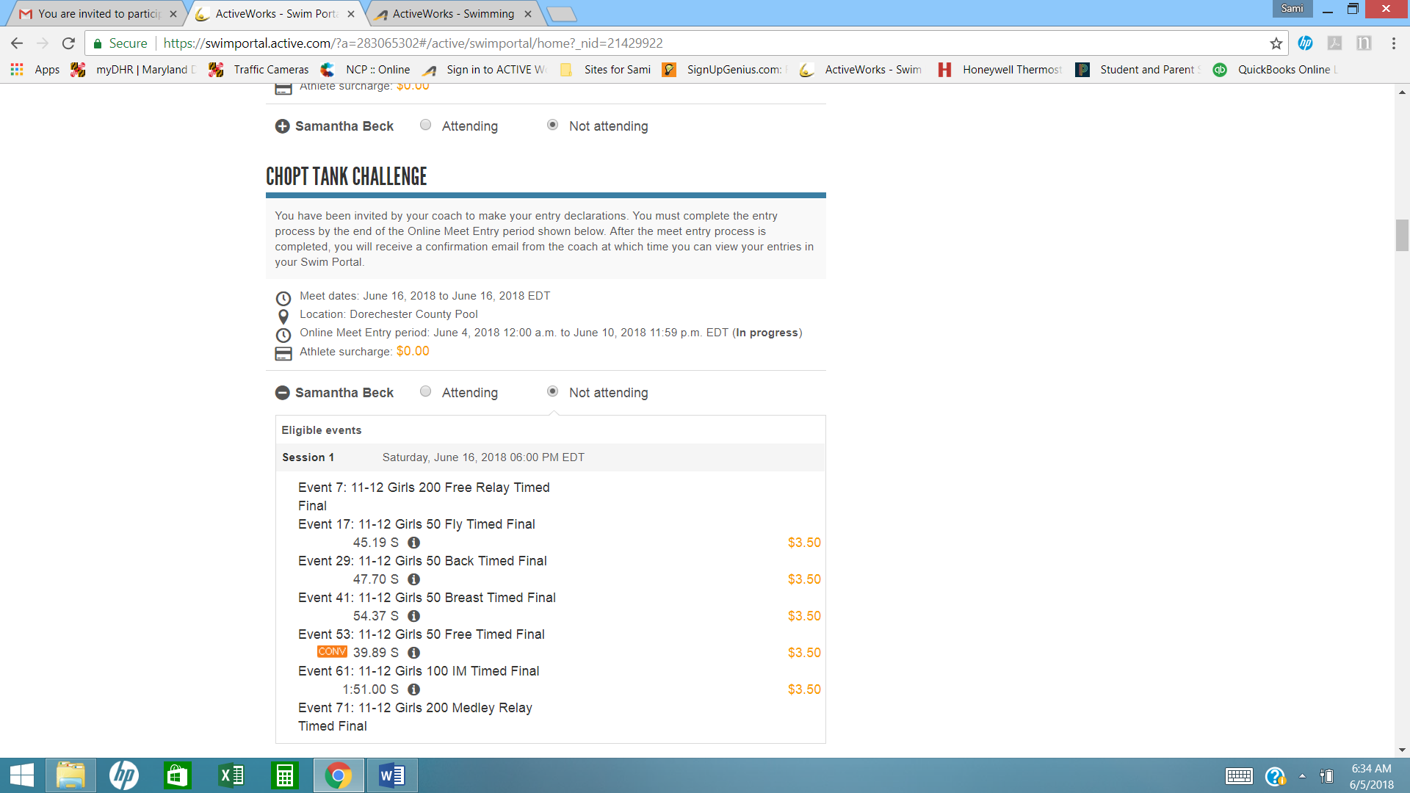

For the optional Invitational meets, our first one is the Choptank Challenge at Dorchester Pool in Cambridge, MD. It is on Saturday, June 18th. You will need to click Attending or Not Attending for each Invitational. Click the Plus sign next to your swimmers name to show the available events that your swimmer can sign up for. The prices are listed as these events cost extra. Email us at [spiritswimparents@gmail.com](mailto:spiritswimparents@gmail.com) once you have signed in as Attending and tell us what events you want your swimmer to swim. Checks are made payable to Sprit Swim Team and MUST be given to us before the event. We will send the details via email of how many events each swimmer can sign up for.